Name : Wilbert Chandra
NIM : 2602113666
- Describe
- Read file and store file to a struct
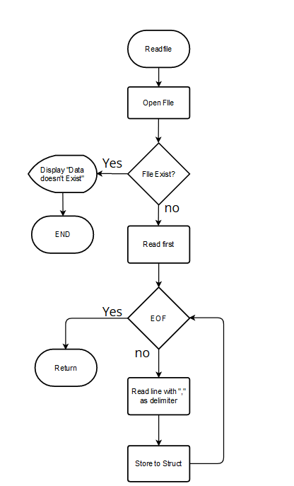
- Describe
  - Describe loc1, loc2, room, bathrooms, carparks, type, furnish
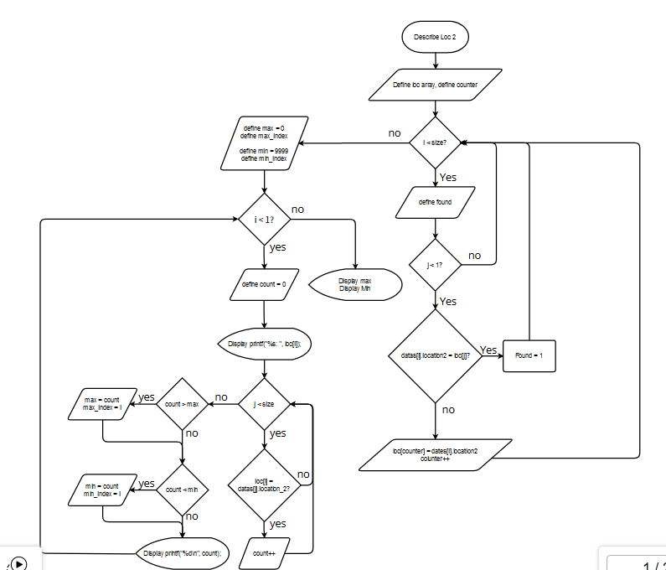
  - Describe price and area

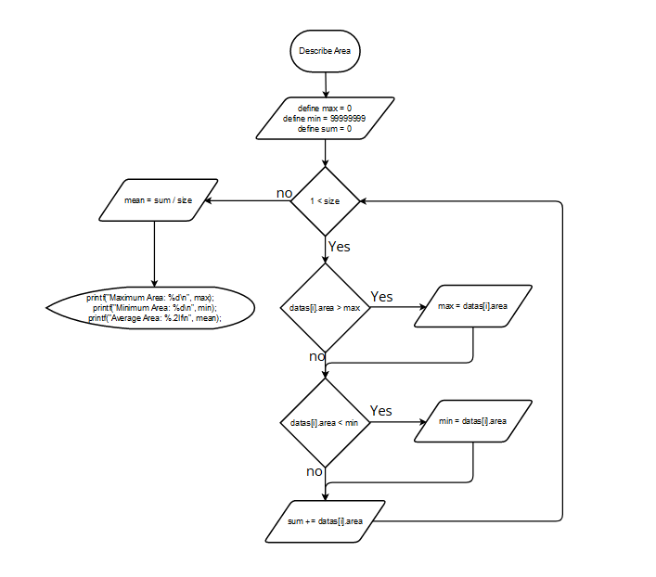

- Search
  - Read file and store file to a struct


  - Search data
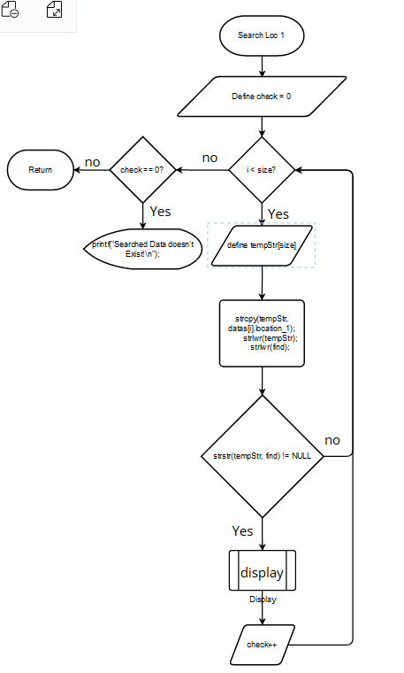
  - Display
